**DATA ANALYTICS FOR HEALTH CARE**

**TEAM ID: PNT2022TMID04319**

**ASSIGNMENT 1:**

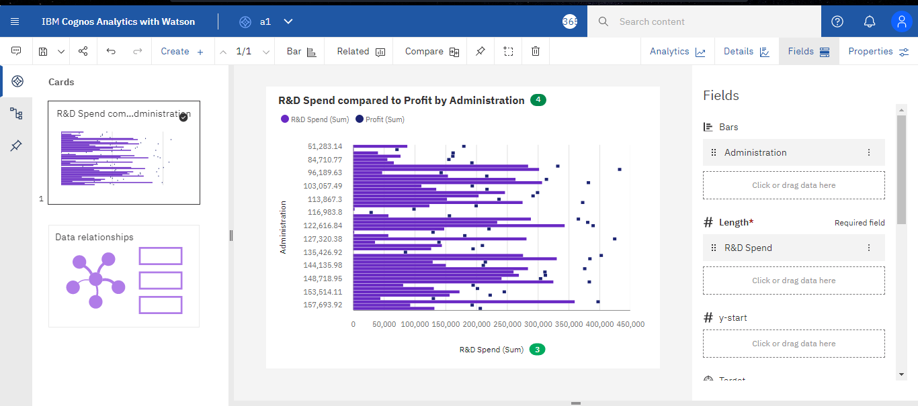

[**https://us3.ca.analytics.ibm.com/bi/?perspective=explore&pathRef=.my_folders%2Fassessment%2B1%2Fa1&subView=model000001833c878224_00000004**](https://us3.ca.analytics.ibm.com/bi/?perspective=explore&pathRef=.my_folders%2Fassessment%2B1%2Fa1&subView=model000001833c878224_00000004)

**ASSIGNMENT 2:**

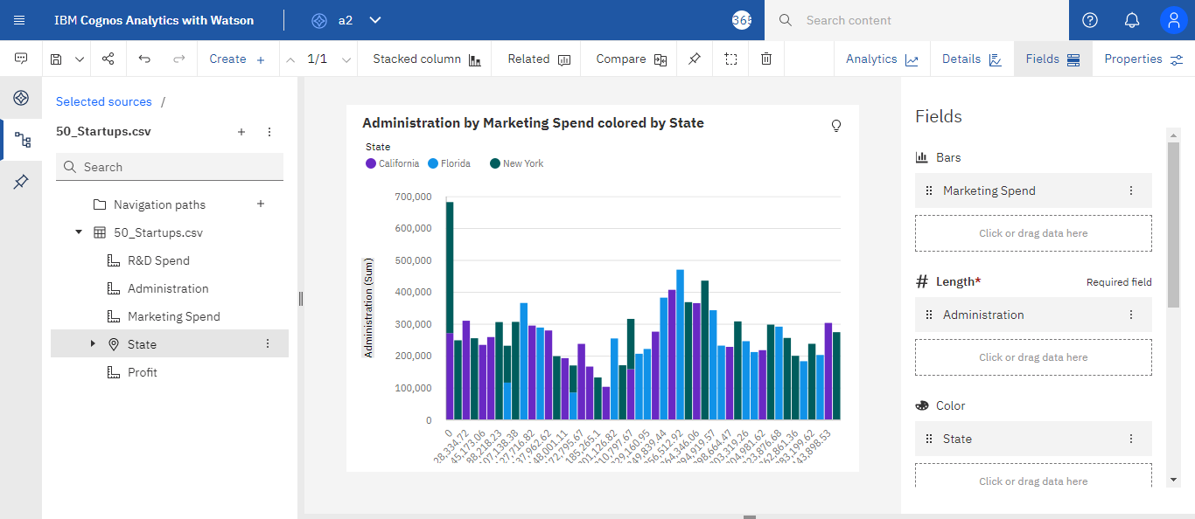

[**https://us3.ca.analytics.ibm.com/bi/?perspective=explore&pathRef=.my_folders%2Fassessment%2B1%2Fa2&subView=model000001833c8c1f5c_00000004**](https://us3.ca.analytics.ibm.com/bi/?perspective=explore&pathRef=.my_folders%2Fassessment%2B1%2Fa2&subView=model000001833c8c1f5c_00000004)

**ASSIGNMENT 3:**

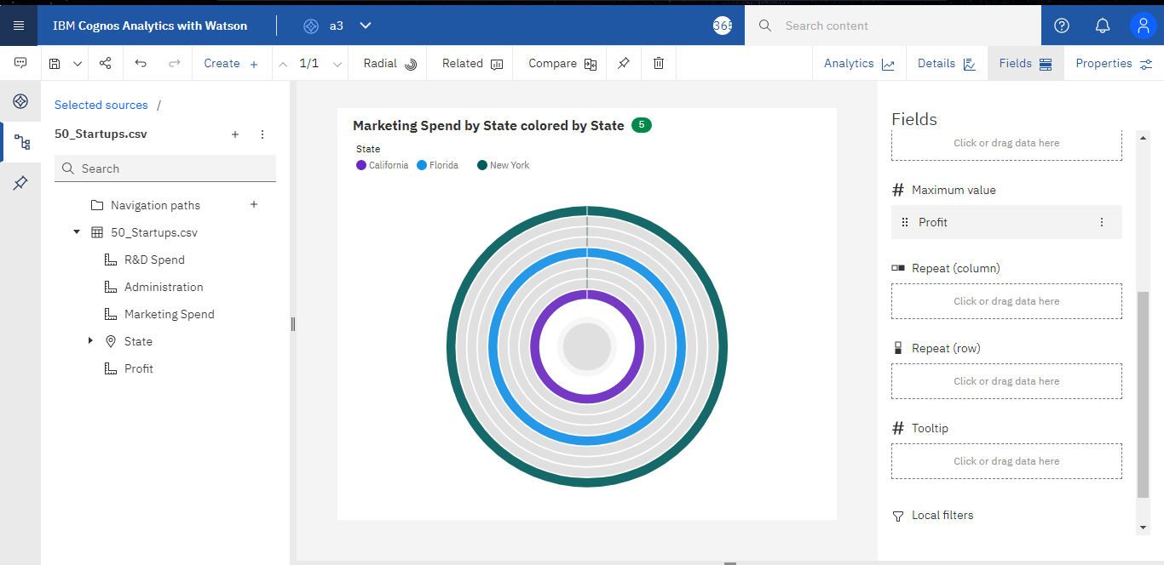

[**https://us3.ca.analytics.ibm.com/bi/?perspective=explore&pathRef=.my_folders%2Fassessment%2B1%2Fa3&subView=model000001833ccb5b6f_00000000**](https://us3.ca.analytics.ibm.com/bi/?perspective=explore&pathRef=.my_folders%2Fassessment%2B1%2Fa3&subView=model000001833ccb5b6f_00000000)

**ASSIGNMENT 4:**

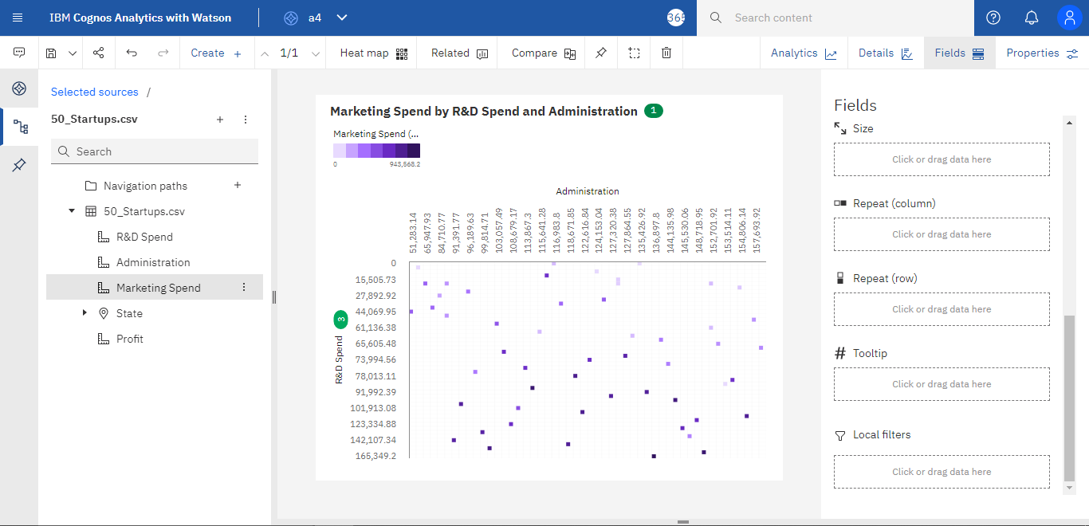

[**https://us3.ca.analytics.ibm.com/bi/?perspective=explore&pathRef=.my_folders%2Fassessment%2B1%2Fa4&subView=model000001833cce6ae1_00000004**](https://us3.ca.analytics.ibm.com/bi/?perspective=explore&pathRef=.my_folders%2Fassessment%2B1%2Fa4&subView=model000001833cce6ae1_00000004)

**ASSIGNMENT 5:**

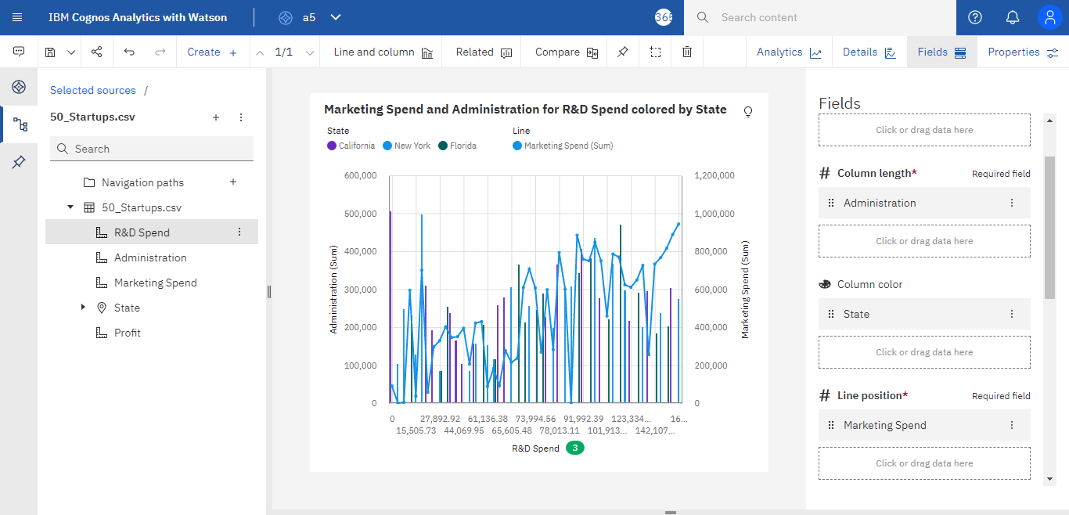

[**https://us3.ca.analytics.ibm.com/bi/?perspective=explore&pathRef=.my_folders%2Fassessment%2B1%2Fa5&subView=model000001833cd092fe_00000004**](https://us3.ca.analytics.ibm.com/bi/?perspective=explore&pathRef=.my_folders%2Fassessment%2B1%2Fa5&subView=model000001833cd092fe_00000004)

**ASSIGNMENT 6:**

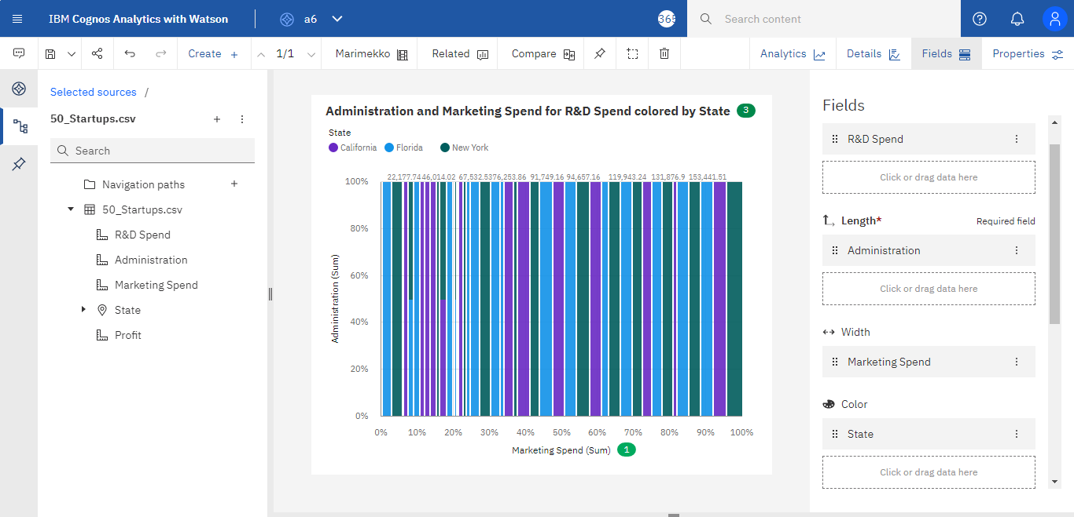

[**https://us3.ca.analytics.ibm.com/bi/?perspective=explore&pathRef=.my_folders%2Fassessment%2B1%2Fa6&subView=model000001833cd2adcb_00000004**](https://us3.ca.analytics.ibm.com/bi/?perspective=explore&pathRef=.my_folders%2Fassessment%2B1%2Fa6&subView=model000001833cd2adcb_00000004)